COURSE CODE/TITLE: | CPE 010 |  | SECTION: | CPE21S3
DATE PERFORMED: | 8/4/26 |  | DATE SUBMITTED: | 8/6/26
NAME: | Ralf Nicolo B. Abello |  | INSTRUCTOR: | Engr. Jimlord Quejado

ACTIVITY NO. 5.1 | Queues
1. PROCEDURE OUTPUT
ILO A
Main.cpp
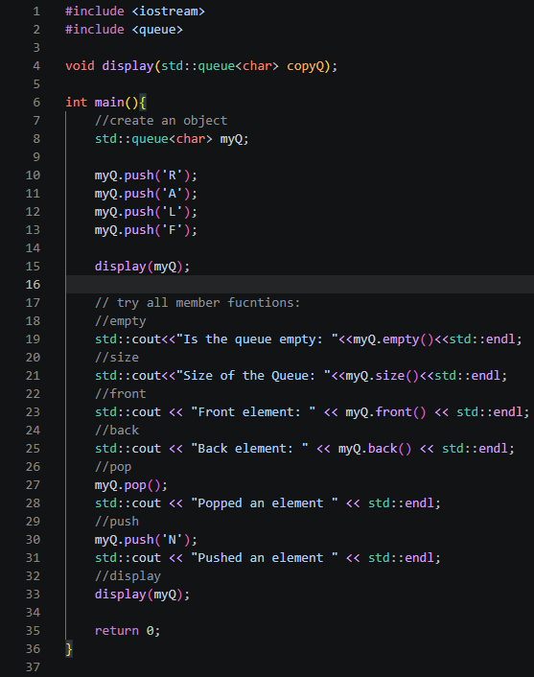

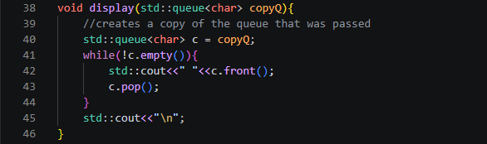

Output
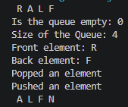

Observation
I observe that display takes copyQ by value and then copies it again into c inside the function, so I'm never touching the actual myQ when I print it. Inside display I use a while(!c.empty()) loop that prints each character with a leading space using c.front() then removes it with c.pop(), continuing until the copy is fully drained, and I finish with a newline through std::cout<<"\n". In main I build myQ by pushing 'R', 'A', 'L', 'F' one at a time, call display(myQ) to see the starting contents, then check myQ.empty() and myQ.size() to confirm the queue state, followed by myQ.front() and myQ.back() to look at both ends without removing anything. After that I call myQ.pop() to remove the front element, then myQ.push('N') to add a new one at the back, and I call display(myQ) again at the end to see how the queue looks after those operations.

ILO B1
Main.cpp
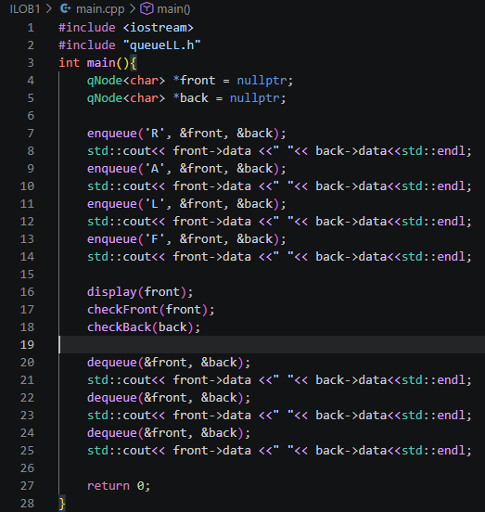

queueLL.h
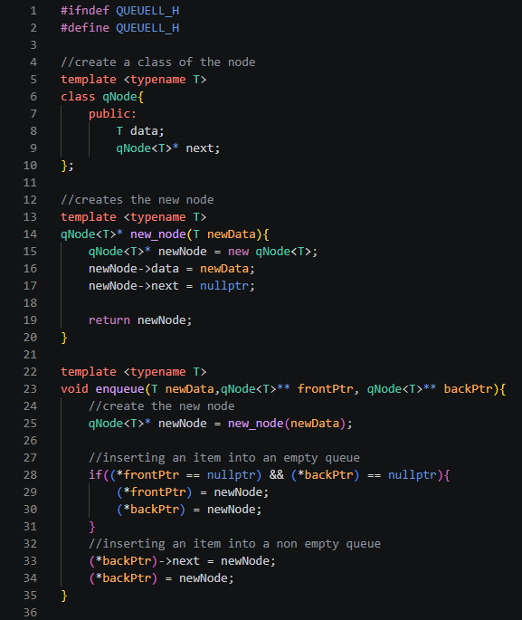
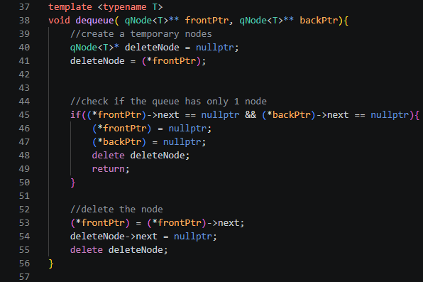
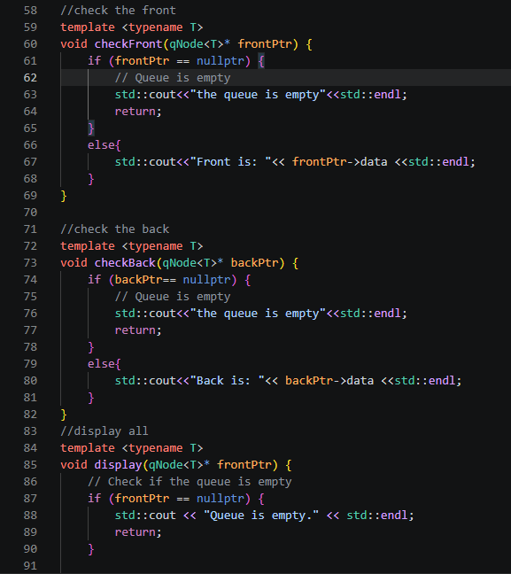
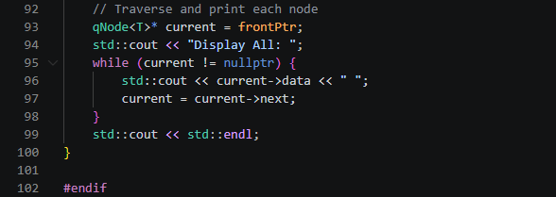

Output
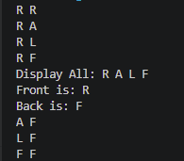

Observation
I observe that this queue implementation uses qNode<T> as a linked list node holding data and a next pointer, with front and back as pointers I pass by address into every function so the underlying pointers can actually be updated. In enqueue I create the node through new_node, then check if both frontPtr and backPtr are nullptr to handle the empty queue case by pointing both to the new node, otherwise I link the new node onto (*backPtr)->next and move backPtr forward. In dequeue I save (*frontPtr) into deleteNode, then check if it's the last node by testing next == nullptr on both front and back, in which case I null out both pointers and delete the node, otherwise I advance (*frontPtr) to (*frontPtr)->next before deleting the old node. I also have checkFront and checkBack as small helper functions that null-check the given pointer before printing its data, and display walks the whole list from frontPtr using a current pointer and a while loop until it hits nullptr, printing each data with a space in between.

ILO B2
Main.cpp
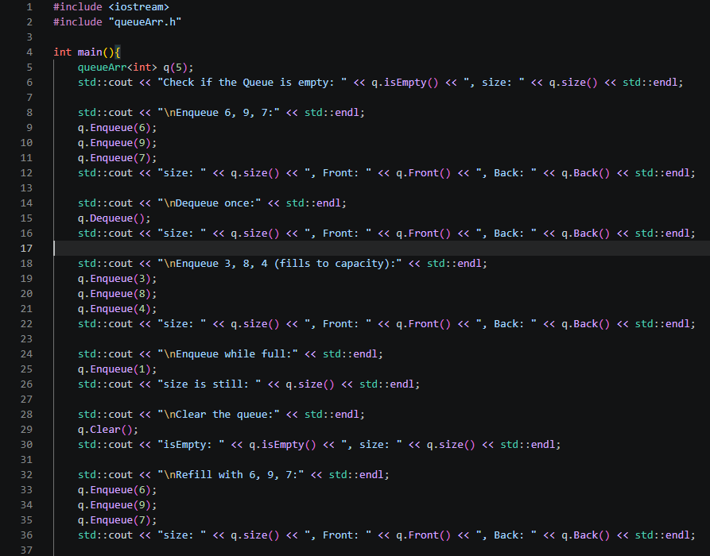
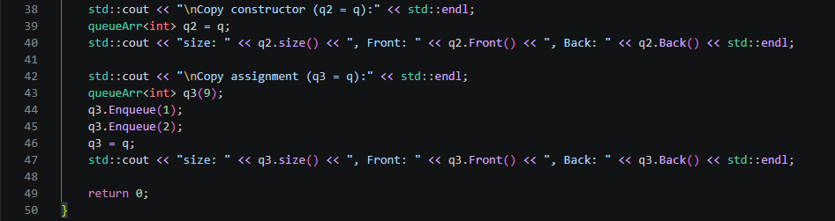

queueArr.h
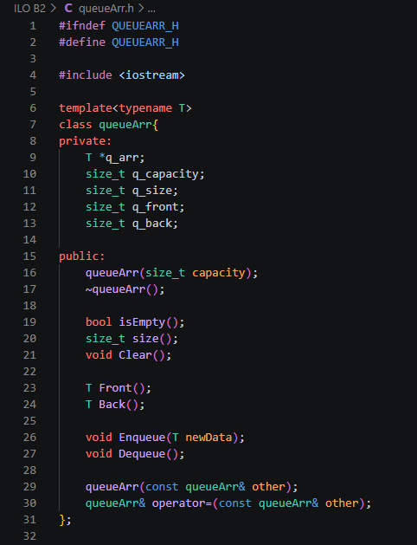
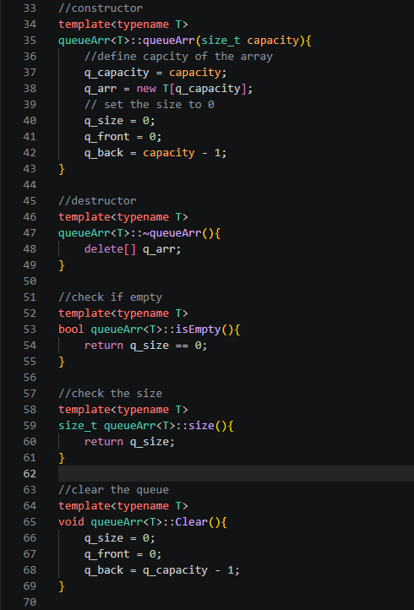
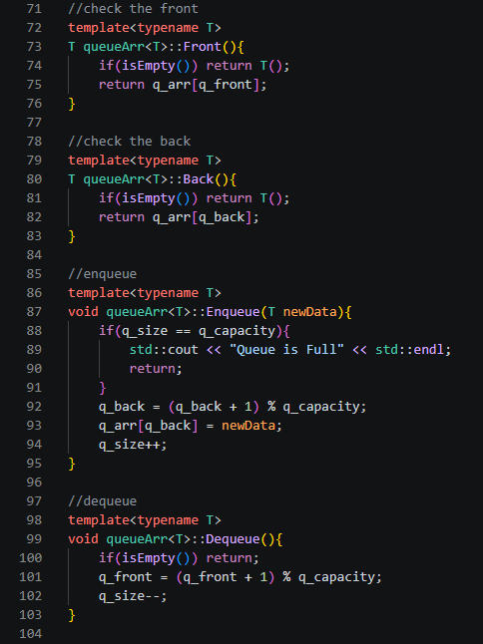
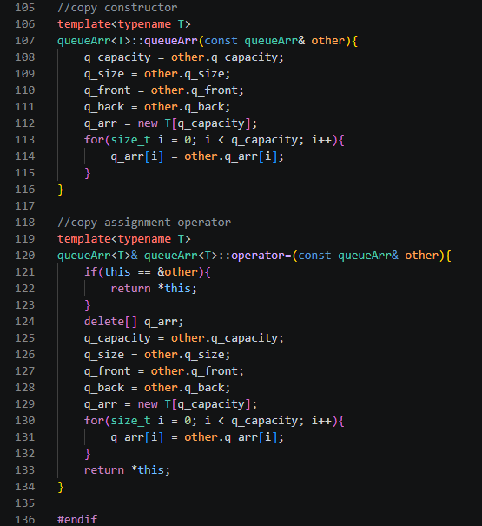

Output
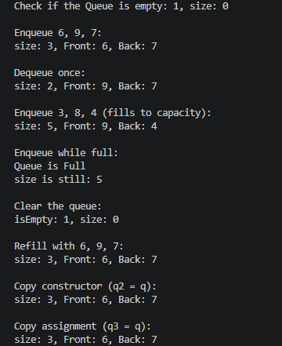

Code Analysis
For my ILO B2, I built a templated queue class inside queueArr.h that uses a regular array, but instead of shifting elements around every time I add or remove something, I just move two index numbers, q_front and q_back, to keep track of where the queue actually starts and ends. I use (index + 1) % q_capacity inside both Enqueue() and Dequeue() so once q_front or q_back reaches the last slot in the array, it wraps back around to index 0 instead of just stopping, which is what makes this a circular queue instead of a normal array that becomes useless once it's full. In my constructor, I create the array with new T[q_capacity] and set q_back to capacity - 1 at the start so my first Enqueue() call can move it to 0 without needing any special case. My copy constructor and copy assignment operator both copy every single slot in the array, not just the slots currently being used, because the actual data can be spread across both ends of the array at once, so copying only part of it would leave some items out. My Clear() function just resets q_size, q_front, and q_back back to their starting numbers without actually deleting anything inside the array, so the old values technically stay there until a future Enqueue() writes over them. Lastly, my destructor calls delete[] q_arr to free up the memory once I'm done using the queue, and I tested that it actually runs correctly by checking the program's behavior in main.cpp before and after each object goes out of scope.

2. ANSWERS TO SUPPLEMENTAL ACTIVITY
ILO C
Main.cpp
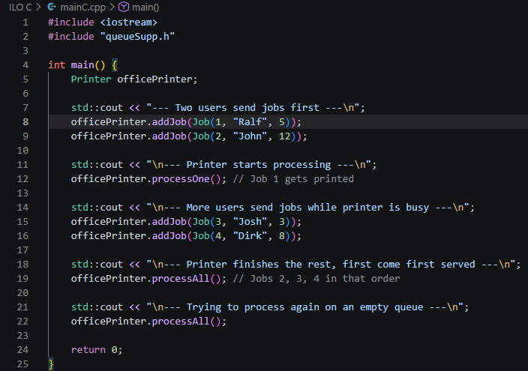

queueSupp.h
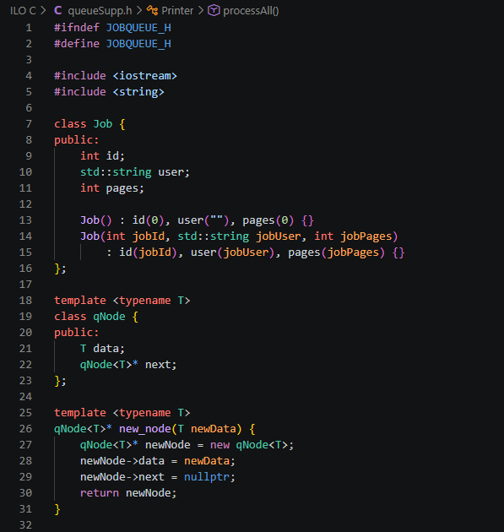
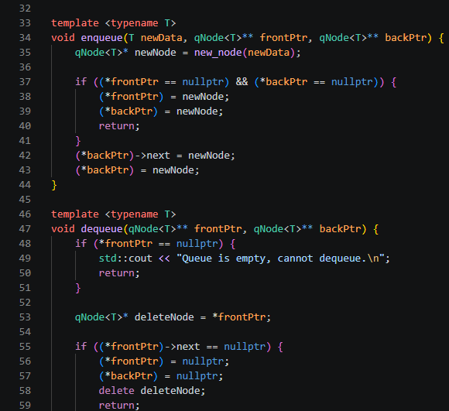
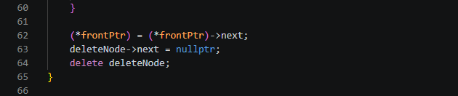
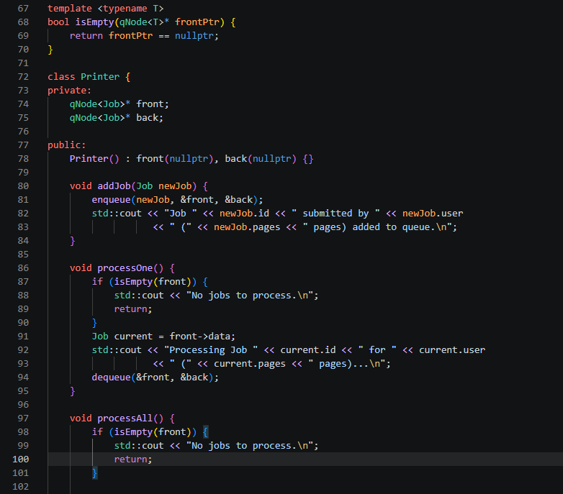
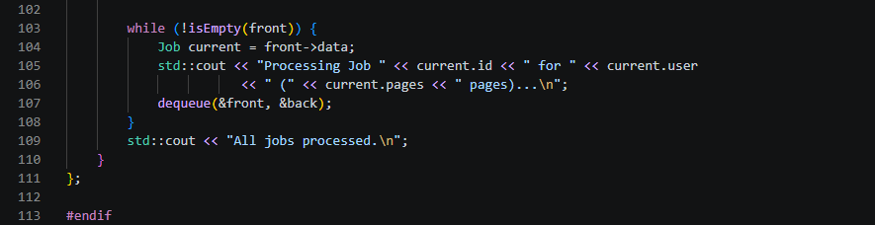

Output
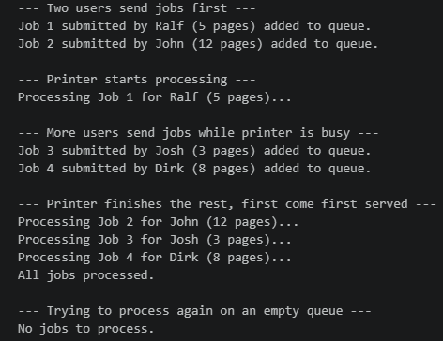

Code Analysis
My output is the way it is because the queue strictly follows FIFO through the front and back pointers, so no matter when I call addJob() or processOne(), jobs always come out in the exact order they went in. Ralf's job prints first since his call to enqueue() made him the very first node, and enqueue() always attaches new jobs at back while dequeue() always removes from front, so there's no way for a job to skip ahead. Even though Josh and Dirk submit through addJob() while the printer is still busy with John's job, they still print after him because processAll() just loops while (!isEmpty(front)), pulling one node at a time and calling dequeue() on it. The "No jobs to process" line at the end shows up because isEmpty() checks if front equals nullptr, which becomes true once dequeue() has emptied the whole list and reset both front and back.

I went with a linked list mainly because a shared printer has no way of knowing in advance how many jobs will show up, so a fixed q_capacity in an array-based version would either be too small during busy periods or too big most of the time. With my linked list, every submission calls new_node() to allocate exactly one more qNode, and every finished job calls delete deleteNode inside dequeue() to free that memory right away, so the queue's size grows and shrinks with actual demand instead of being capped. It also skips the wraparound math I needed in my ILO B2 array version, since nodes just connect and disconnect through their next pointers instead of needing something like (index + 1) % q_capacity to reuse freed space.

Conclusion
In this activity, I learned how to actually implement a queue from scratch using both an array-based and a linked list approach instead of just relying on the STL, which gave me a much clearer picture of how queues really work behind the scenes. For the main procedure, I noticed that the array-based version was mostly about managing positions carefully so the queue could keep reusing space efficiently, while the linked list version relied more on properly handling empty and single-item cases so I wouldn't run into memory issues after adding or removing items. The supplementary activity tied both concepts together well since simulating a shared printer gave me a real-world reason to choose one data structure over another, and it helped me understand why a linked list fits situations with unpredictable, continuous data better than a fixed-size array would. Overall, I think I did fairly well on this activity since all my functions worked as expected and consistently followed proper FIFO behavior across every test case I ran, though I could still improve on catching small logic errors earlier instead of only noticing them while testing, so next time I'll try to trace through my logic more carefully before running the code.

3. ARTIFICIAL INTELLIGENCE (AI) USE DISCLOSURE STATEMENT
I hereby declare that artificial intelligence (AI) tools were used, if applicable, in the preparation of this academic work. The following indicates the nature and extent of AI assistance:

Tools Used: | ChatGPR & Grammarly
Examples: ChatGPT, Microsoft Copilot, Grammarly, QuillBot, etc.

Purpose of Use: | Grammar Correction & Code assistance
Examples: grammar correction, idea generation, formatting, summarization, code assistance, explanation of concepts, etc.

Extent of Use: | Helped me debug along the way while making my supplementary
Explain how AI was used and confirm that it did not replace original thinking, analysis, authorship, or completion of the required work.

By submitting this activity, I affirm that my use of AI complies with T.I.P.’s AI usage policy and does not exceed the permitted limits for similarity, automated content generation, or academic assistance.

I understand that any false, incomplete, or misleading disclosure may be subject to investigation in accordance with due process and may result in sanctions for violation of existing T.I.P. policies.

Lab activities, templates, and related instructional materials shall not be reuploaded, reproduced, distributed, or shared with external organizations or third parties without the prior express written permission of the Technological Institute of the Philippines.

